Graduation Art
This year we’re keeping it simple with some name (signature) art, which we hope to transform into some digital art!

There are 3 mini tasks:

Signature task
- Write your signature (first name only) clearly on a plain white piece of paper. This ideally needs to be done (or gone over) in black pen or a fine-tip dark-coloured marker.
- Place this piece of paper on a table or level-surface and take a picture of it directly over it (up close).
- Send this back to us on Aladdin or by email (admin@naascns.ie)

Example:
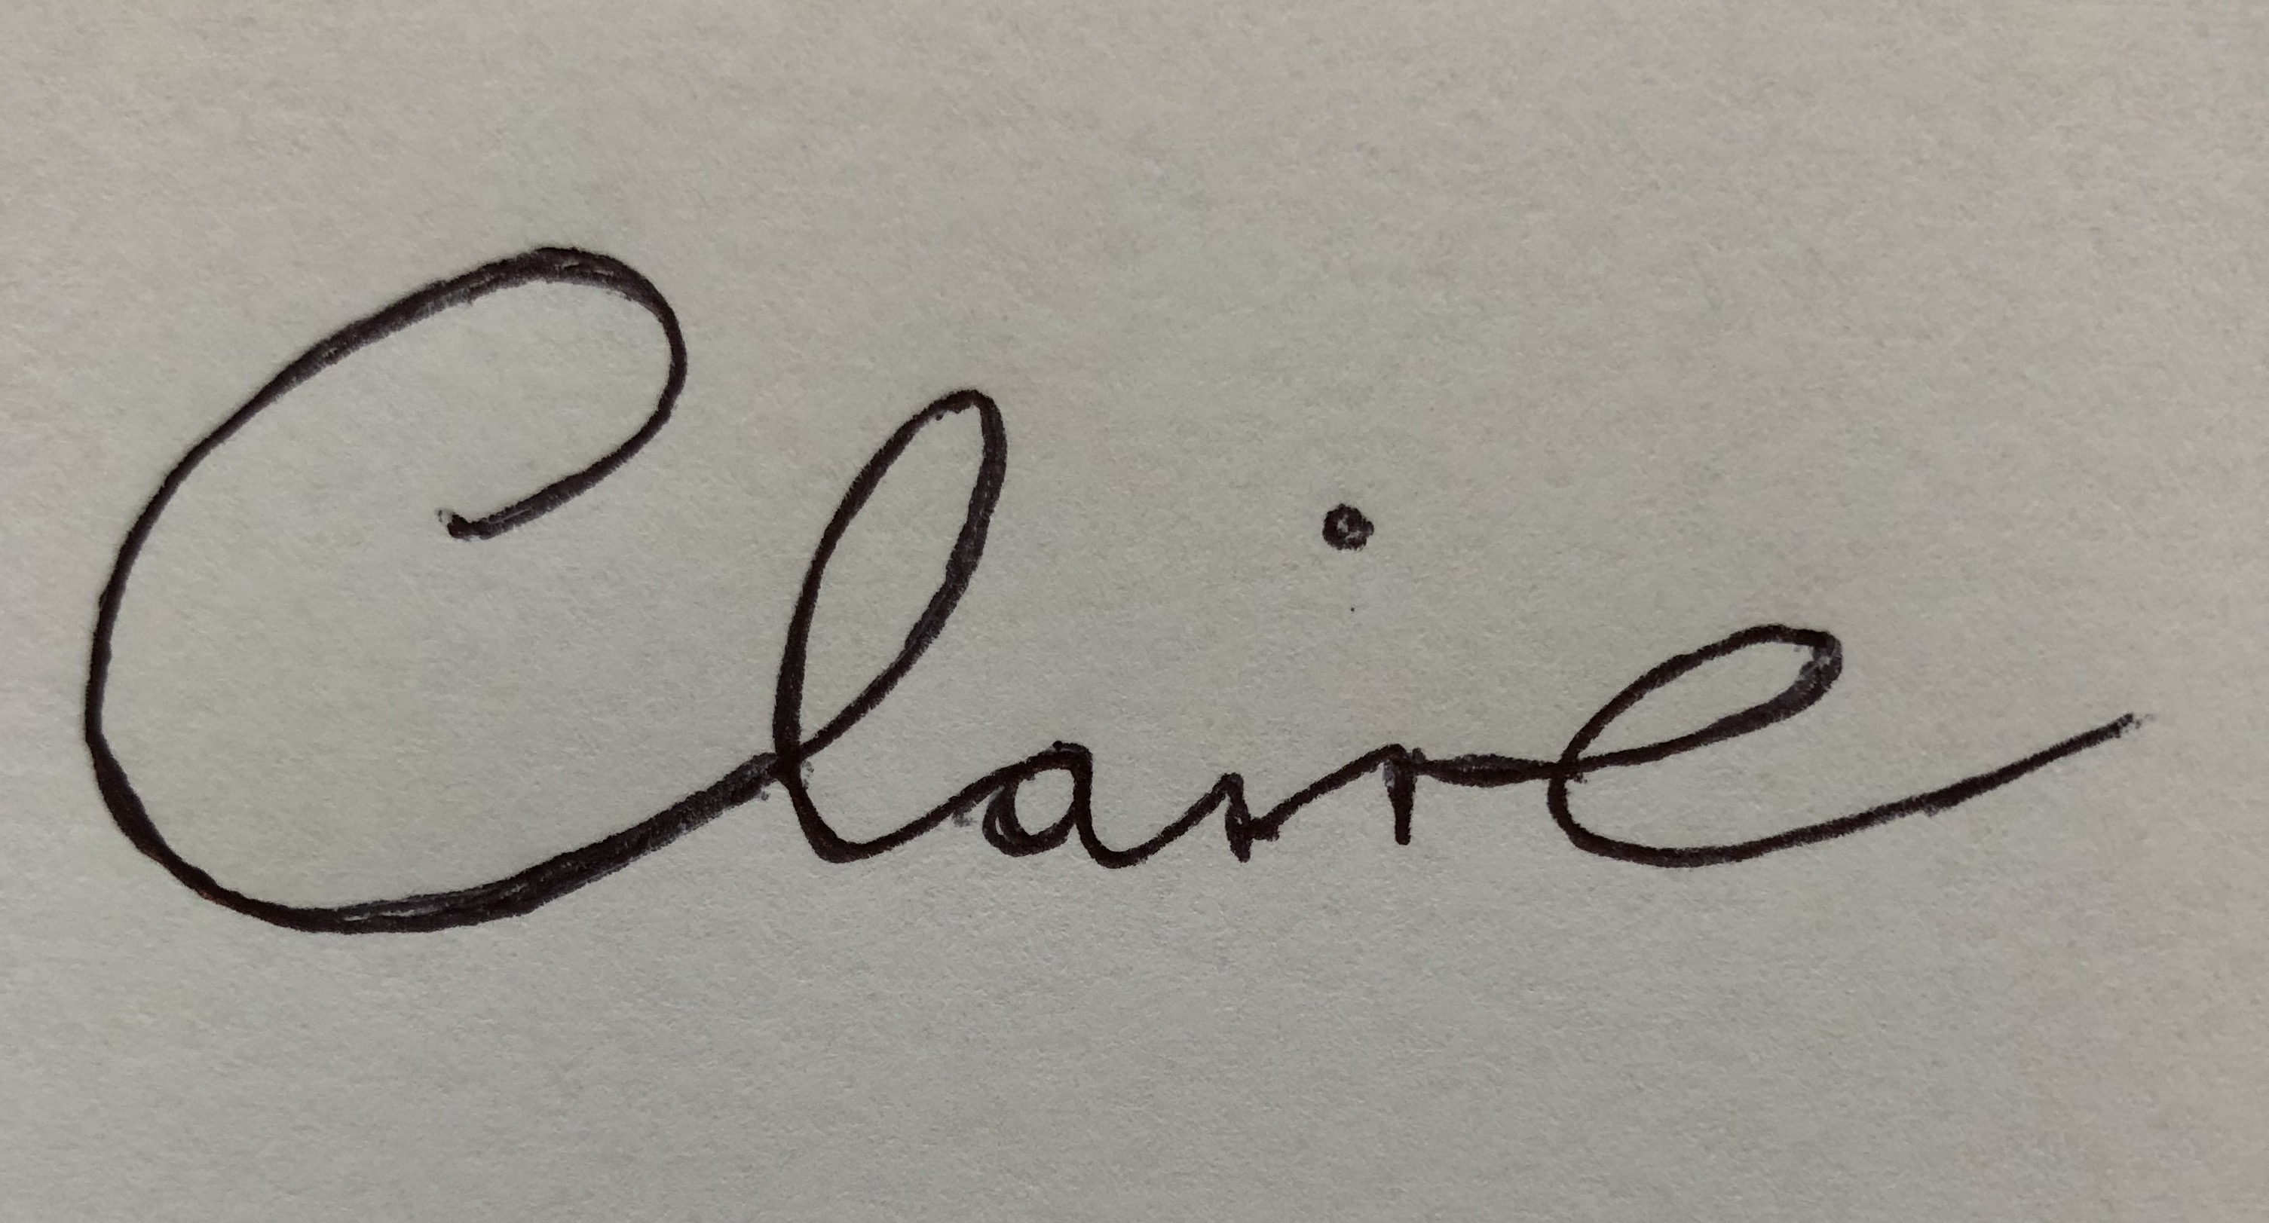

Doodle task
- On a new page, create a simple line drawing/doodle/sketch on the theme of graduation. The theme is open to your interpretation, but here are some ideas to get you started: a doodle of a graduation cap/ a book/ a globe/ a star/ a trophy/ a scroll/ a person graduating etc.). This doodle does not need to be detailed, it’s a quick sketch that should only take a few minutes. Please do not colour it in. The drawing ideally needs to be done (or gone over) in black pen or a fine-tip dark-coloured marker.

Alternative option: If you do not wish to do a drawing, you could alternatively write a quote that is meaningful to you, that ties in with the theme of graduation (e.g. "Don't cry because it's over, smile because it happened." - Dr. Seuss). Again, this would need to be clearly written and done (or gone over) in black pen or a fine-tip dark-coloured marker.

- Place this piece of paper on a table or level-surface and take a picture of it directly over it (up close).
- Send this back to us on Aladdin or by email (admin@naascns.ie)

Example:

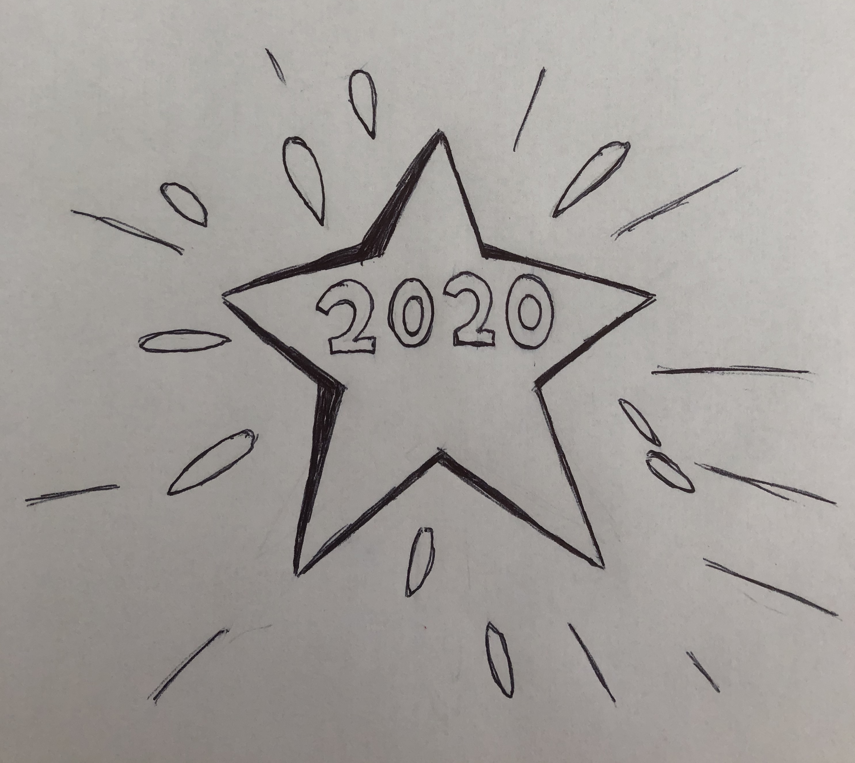

Favourite colour
Finally, let us know what your favourite colour is when you are sending back your signature and doodle art (this can be written in the message field on the homework section on Aladdin, or by email).

Thanks boys and girls, I hope to convert these to digital files on my computer, and no doubt they will look great when we put them all together!

PS. If you wish to create any additional pieces of art for graduation yourself in paint or colour please take photos and send them in, I would love to see them and we can try to incorporate them into our Graduation ceremony!

